VNU ASIA PACIFIC AND PT GLOBAL PERMATA PERKASA JOIN FORCES AND PRESENT AQUATICA ASIA, CO-LOCATED WITH ILDEX INDONESIA

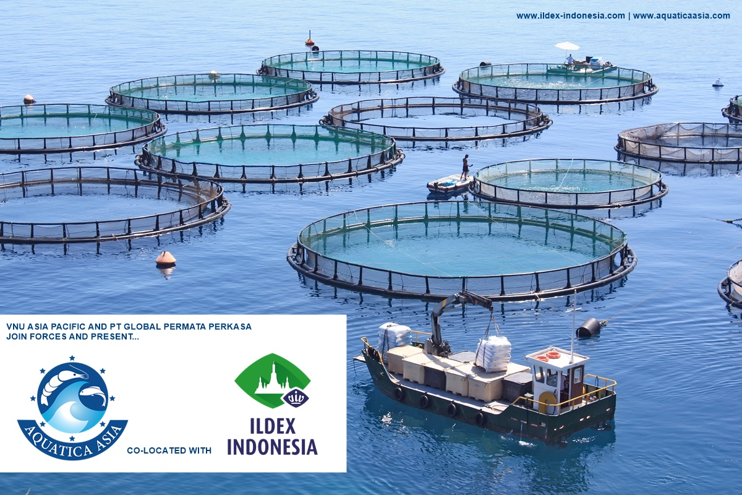
Photo of the Opening Ceremony of ILDEX Indonesia 2019

BANGKOK - JAKARTA – August 13, 2020 – Over the past 10 years, VNU Asia Pacific (VNU AP) has been organizing the International Livestock, Dairy, Meat Processing and Aquaculture Exposition (ILDEX Indonesia) in collaboration with PT Permata Kreasi Media (PKM). As PKM transitions to a new business entity named PT Global Permata Perkasa (GPP), the group is working to develop a pilot project – Aquatica Asia.

Aquatica Asia aims to strengthen the Aquaculture Industry and will launch alongside ILDEX Indonesia. It will take place on odd-numbered years beginning September 15-17, 2021 at the Indonesia Convention Exhibition (ICE) in Jakarta. During even-numbered years Aquatica Asia will co-locate with a local government show.

Business Opportunities for the Aquaculture Sector

Aquatica Asia will be a strategic step towards a dedicated business platform to improve the production of fisheries within the aquaculture industry. In past years, organizers have worked to include the aquaculture segment in ILDEX Indonesia, however, the new event will help to further highlight the industry for the existing show and industry professionals.

“In 2020, Indonesia’s marine affairs and fisheries is one of the three main sectors contributing to the country’s economic development. The efforts done by the Indonesian Ministry of Marine Affairs and Fisheries are the appropriate steps. These efforts include improvements of fisheries production and commodities that have been dominating both exports and local markets such as shrimps, seaweed, catfish, grouper, etc. Another part of the efforts was the initiative of GPP to run Aquatica Asia in 2018 with fishery stakeholders co-locating with Indo Aqua under the support of the Ministry of Marine Affairs and Fisheries of the Republic of Indonesia by Directorate General of Aquaculture” stated Panadda Kongma, Director of Agri-business and Operations of VNU Asia Pacific.
Panadda Kongma, Director of Agri-business and Operations of VNU Asia Pacific

“VNU-AP has gathered valuable insights on the entire agribusiness value chain in the region, and the two parties will further develop good relationships with regional key stakeholders”, said by GPP managing Director is Mr. Ir. Ruri Sarasono, MBA.

Full Coverage of the Livestock–Aquaculture Value Chain

To maximize the customer’s return on investment, ILDEX Indonesia and Aquatica Asia will together present a full value chain of animal breeding, animal health, animal housing & farm equipment, industrial feed, grain & raw material processing equipment, feed, feed ingredients/additives, fish processing, seasoning, packaging, handling, refrigeration, laboratory, testing equipment and services, logistics & handling, wastewater treatment and hatching/incubation for livestock and aquaculture businesses.
Mr. Ir. Ruri Sarasono, MBA., Managing Director of Global Permata Perkasa

The events will cover over 10,000 sq.m. of the Indonesia Convention Exhibition (ICE). Since 2018, ILDEX has had key buyers throughout their editions and activities. 200 key buyers, who passed qualifying criteria, were invited from ASEAN countries and will continue the Hosted Buyer Program for ILDEX Indonesia 2021, co-located with Aquatica Asia. Key buyers will focus on Livestock and Aquaculture sectors and come from the exhibitor’s research and referral, who recommends potential key buyers that they meet onsite. ILDEX Team will prepare welcome packages and special privileges for buyers.

ILDEX Indonesia 2019 Success Story

In 2019, ILDEX Indonesia had greater attendance than its past editions, when it was relocated to the new venue at the Indonesian Convention Center (ICE). The exhibition space increased and showcased 250 leading brands from 25 countries with 73% being international exhibitors. The main business sectors at ILDEX include animal health, animal housing & farm equipment, animal feed & ingredients, breeding & genetics, incubation & hatchery, and slaughter to processing. The show welcomes 200 hosted buyers and 80 businesses through the business matching system.

ILDEX Indonesia 2019 welcomed over 12,200 trade visitors from 40 countries. During the 3-day exhibition, more than 2,032 conference delegates attended the 48 seminars.

New Look and New Features for ILDEX Indonesia

The VNU management team combined the ILDEX Exhibition into the VIV Portfolio to boost and develop both shows. VIV’s mission is to continue linking professionals from Feed to Food. As part of the VIV Portfolio, the ILDEX Exhibitions will strengthen VNU AP’s outreach in Vietnam and Indonesia markets. The new look of ILDEX Indonesia will include a diamond frame as symbol of VIV as well as the Borobudur National Landmark of the country.

ILDEX Indonesia and Aquatica Asia are scheduled for September 15-17, 2021 at the Indonesian Convention Exhibition (ICE) in Jakarta.
###

For more information (International), please visit www.ildex-indonesia.com | www.aquaticaasia.com
Tel: +662 1116611, Email: ildex@vnuasiapacific.com / saengtip@vnuasiapacific.com (Communications)

Indonesia Office Jl. Pandawa Raya B2 No 7, Indraprasta, Bogor City 16153
Tel: +62 251 834 5186, Email: info@aquaticaasia.com

About VNU Asia Pacific

VNU Asia Pacific is part of the VNU Group, a globally operating exhibition company with offices in Utrecht, Shanghai and Bangkok, and consolidates the international exhibition business of Royal Dutch Jaarbeurs. In South East Asia, Jaarbeurs has formed a Joint Venture with TCC Assets, a leading corporate conglomerate in the fast-growing region. From its business hub in Bangkok, VNU Asia Pacific covers all key exhibition markets in South East Asia. VNU Asia Pacific has a constantly expanding portfolio including brands from the AgriTech, Animal Husbandry, Animal Companion, Food, Life Sciences and Biotechnology industries. Royal Jaarbeurs belongs to the top 20 exhibition organizers by revenue worldwide and operates a 100,000 square meter exhibition center in the city of Utrecht, in the Netherlands. The Thai counterpart, TCC Assets (Thailand), is one of South East Asia’s most recognized corporations. The portfolio of TCC Assets includes real estate development, hospitality services, as well as engineering and lifestyle services.
For more information, visit www.vnuasiapacific.com / (Communication issue) saengtip@vnuasiapacific.com

About Global Permata Permata Perkasa, PT

Global Permata Perkasa (GPP) is a limited liability company (PT) which was established as a manifestation of the desire of fisheries industry stakeholders to conduct business in the field of MICE (Meeting, Incentive, Conference, Exhibition) in a professional and sustainable manner GPP has held the AQUATICA ASIA exhibition annually since 2018, in collaboration with the INDOAQUA exhibition which is fully supported by the Ministry of Marine Affair and Fisheries of the Republic of Indonesia (KKP, RI) through the Directorate General of Aquaculture, KKP RI.

